Homework Assignment 3

Rahul Avadhoot

October 11, 2017

fev2 <- read.csv("http://faculty.washington.edu/tathornt/Biost509/DataSets/fev2.csv",header = TRUE)

## Question 1

plot(x = fev2$age,  
 y = fev2$fev,  
 xlab = "Age",  
 ylab = "Measured FEV (liters per sec)",  
 main = "Scatterplot of FEV vs Age")

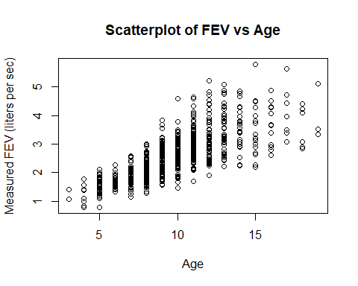

There appears to be a linear increse between Measured FEV between the ages 5 to 13. After age 13, the Measured FEV plateaus and data is sparse to conclude anything qualitatively.

## Question 2

plot(x = fev2$age,  
 y = fev2$fev,  
 xlab = "Age",  
 ylab = "Measured FEV (liters per sec)",  
 main = "Scatterplot of FEV vs Age",  
 col = ifelse(fev2$sex == 2, "red", "gray50"))

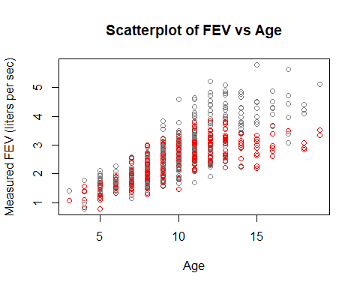

## Question 3

boxplot(fev~interaction(smoke),  
 data = fev2,  
 xlab = "Smoking Habit",  
 ylab = "Measured FEV (liters per sec)",  
 main = "Boxplots of FEV for both Smoking Habits")

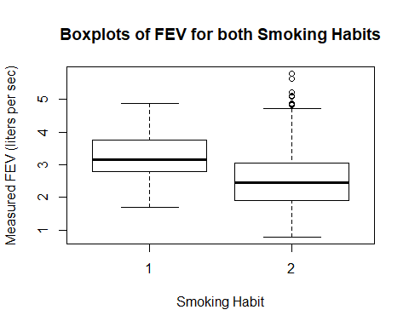

The measured FEV value of smokers is significantly greater than that of non smokers.

## Question 4

fev2$group<-ifelse(fev2$age <= 5,1,ifelse(fev2$age > 5 & fev2$age <= 10,2,ifelse(fev2$age > 10 & fev2$age <= 15,3,ifelse(fev2$age > 15 & fev2$age <= 20,4,5))))

fev2$smokefactor <- as.factor(fev2$smoke)  
plot(smokefactor~interaction(group),  
 data = fev2,  
 xlab = "Age Groups",  
 ylab = "Proportion of Smokers",  
 main = "Proportion of Smokers by Age Group")

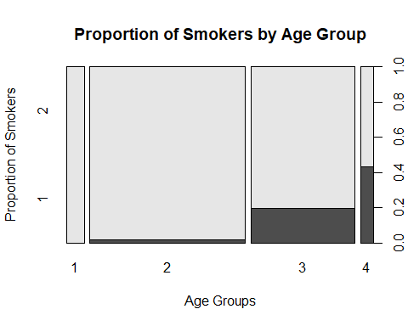

## Question 5

boxplot(fev~interaction(group),  
 data = fev2,  
 xlab = "Age Groups",  
 ylab = "Measured FEV (liters per sec)",  
 main = "Boxplots of FEV for all Age Groups")

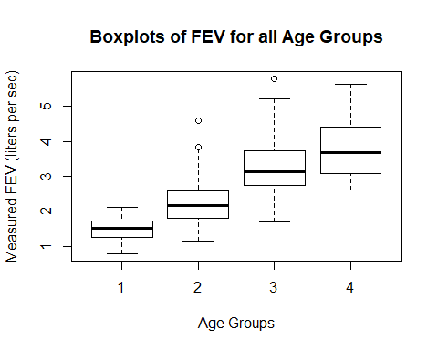

The measured FEV values has a linear relationship with Age as observed in the boxplots above.

## Question 6

boxplot(fev~interaction(smokefactor,group),  
 data = fev2[fev2$group != 1,],  
 xlab = "Smoke Factor . Age Group",  
 ylab = "Measured FEV",  
 main = "FEV by Smoking Habits for each Age Group")

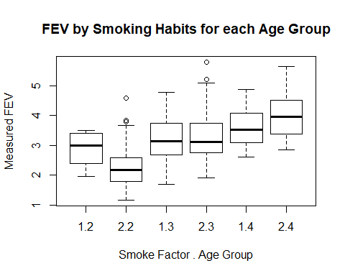

Age Group 1 (ages 1 to 5) is omitted as it had no smokers.

In Age Group 2 (ages 6 to 10), there was considerable difference in the measured FEV values of smokers and non smokers. The measured FEV values of non smokers was lesser than that of smokers.

In Age Group 3 (ages 11 to 15), there is little difference in the FEV values of smokers and non smokers.

In Age Group 4 (ages 16 to 20), the measured FEV values of smokers was lesser than that of non smokers.

## Question 7

coplot(fev~height| age, number = 4,  
 data = fev2,  
 xlab = "Height",  
 ylab = "Measured FEV")

